## [http://localhost:8080/prweb/PRSOAPServlet/SOAP/ALFAPack/VINValidationService?WSDL](https://www.google.com/url?q=https://www.google.com/url?q%3Dhttp://localhost:8080/prweb/PRServlet/app/ALFAAUTO_/3RgaLFemDCaE7qAG3yL-rlyMIci6oLkh*/!PS1__TABTHREAD0?pyActivity%253D%252540baseclass.doUIAction%2526action%253DopenRuleSpecific%2526openHandle%253DDATA-ADMIN-SERVICEPACKAGE%252520ALFAPACK%2526Format%253Dharness%2526contentID%253D9ad18b0f-8aea-acd6-e41a-a77e8fd012e8%2526dynamicContainerID%253Dde12ecd7-b2b3-4849-bff1-ee2797014513%2526tabIndex%253D2%2526portalThreadName%253DOpenPortal_Developer%2526portalName%253DDeveloper%2526pzHarnessID%253DHIDCFCF127532A9D8F90818CFA3899279EF%26amp;sa%3DD%26amp;source%3Deditors%26amp;ust%3D1620642153778000%26amp;usg%3DAOvVaw2GeH_bmTB-CaDRpVUv32O3&sa=D&source=editors&ust=1620642153809000&usg=AOvVaw1jMxVL7O17PeO2K9Q5MAq5)

=============

**Working with Connect SOAP:**

**Connect SOAP**

**XML Stream**

**Parse XML**

**Req: Consume VIN Validation service to populate VIN Details based VINNO**

**Note: Once we get the WSDL Url, we can run connector & Metadata wizard which will create all the required rules to consume the service.**

**- While Consuming the Service we use Organization Int Layer. Organization Int Layer is already available.**

**Open Connector & Metadata Wizard:**

**Configure-> Integration->  Connectors-> Create SOAP Integration**

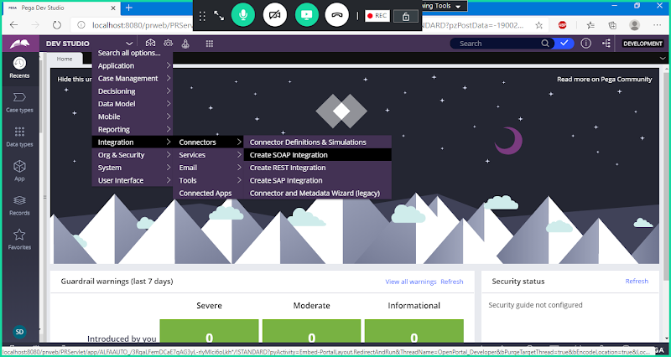

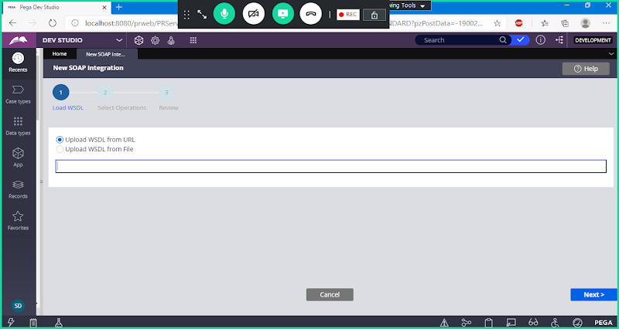

**Enter Service Url**

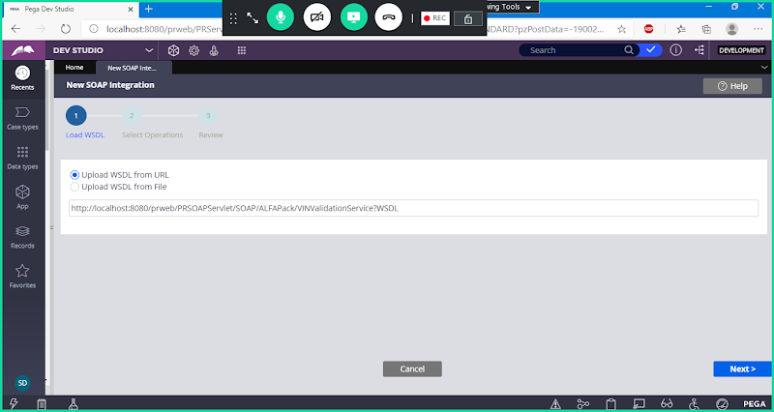

**Next**

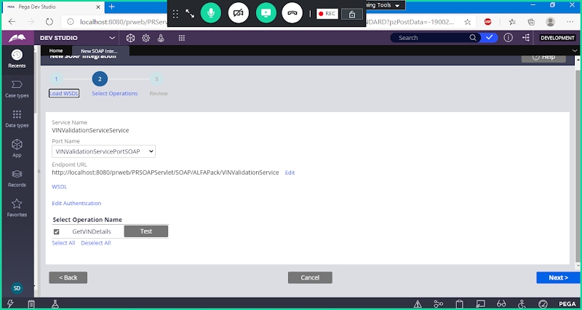

**Next**

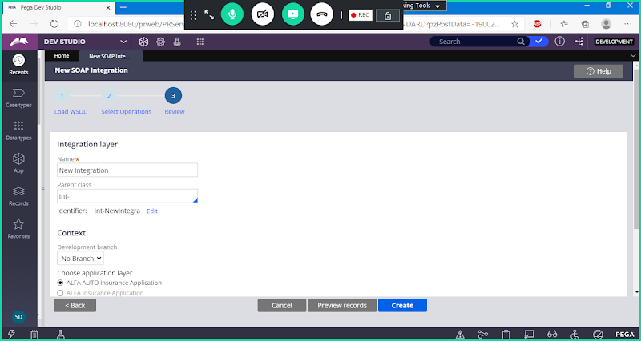

**Change Integration Name:**

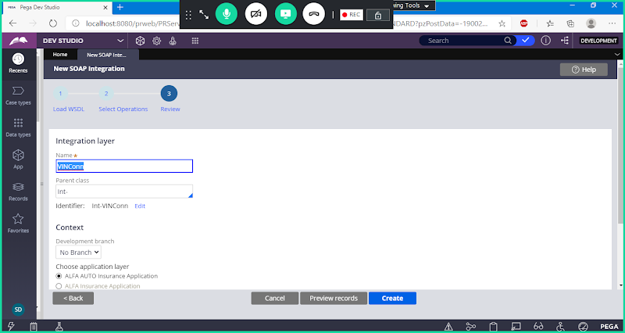

**Click on Create**

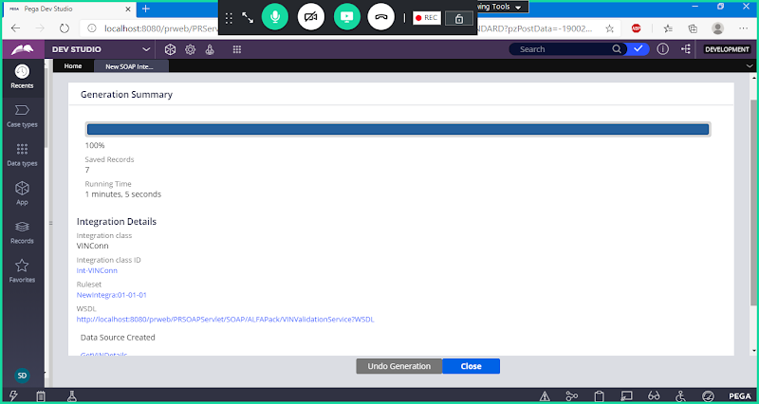

**To Check all the Rules we can check under : Int-VINConn**

**Create Activity Under Work Layer**

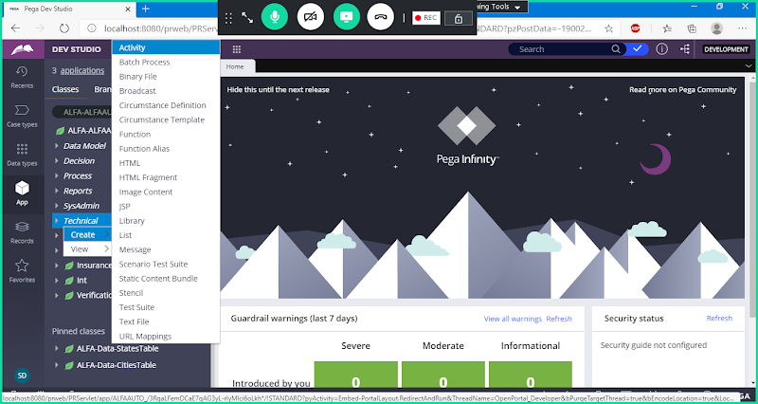

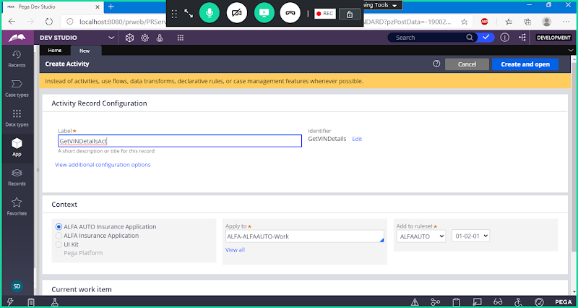

**Here Activity will be created to Call Connect-SOAP & Mapping Request & Response Properties**

**Open ACtivity & Define Pages & Classes**

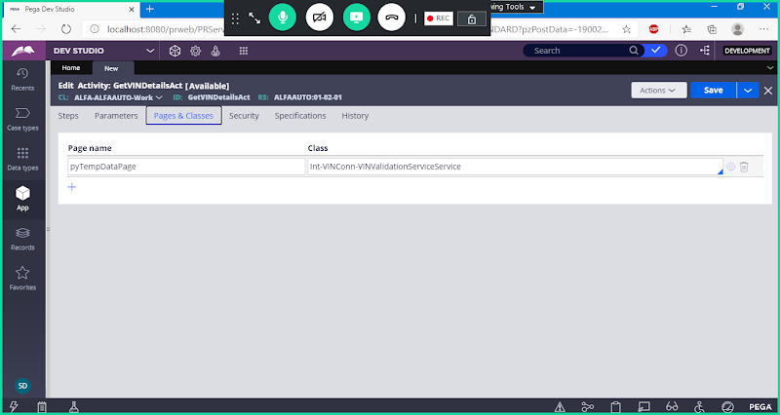

**Go to Security Tab**

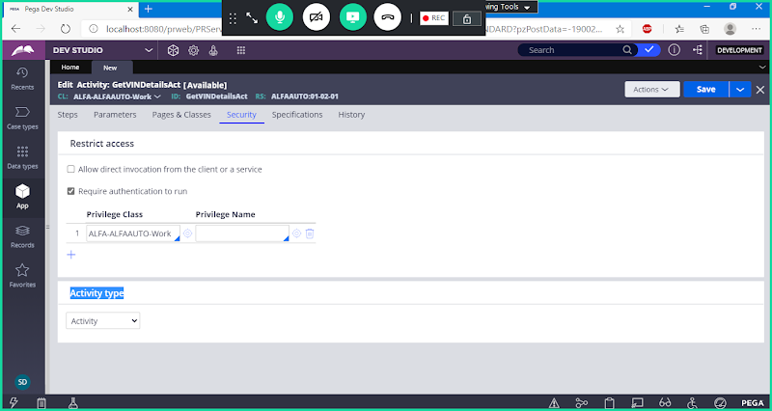

**Change Activity Type to Rule Connect**

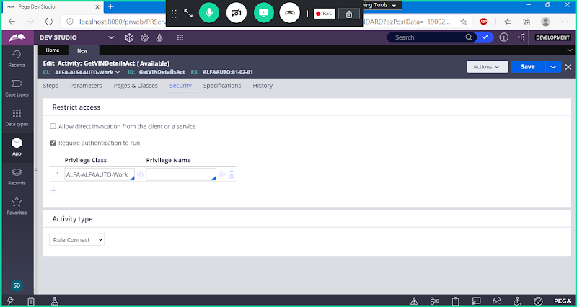

**Now go to Setps Tab:**

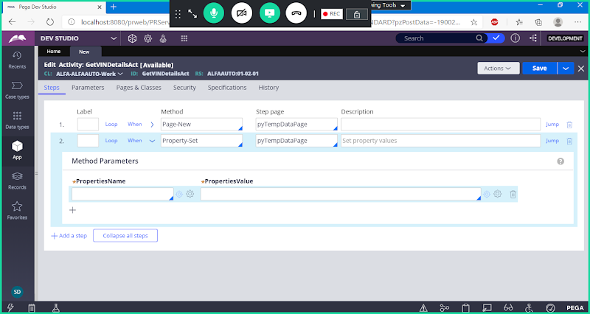

**Map Request Property**

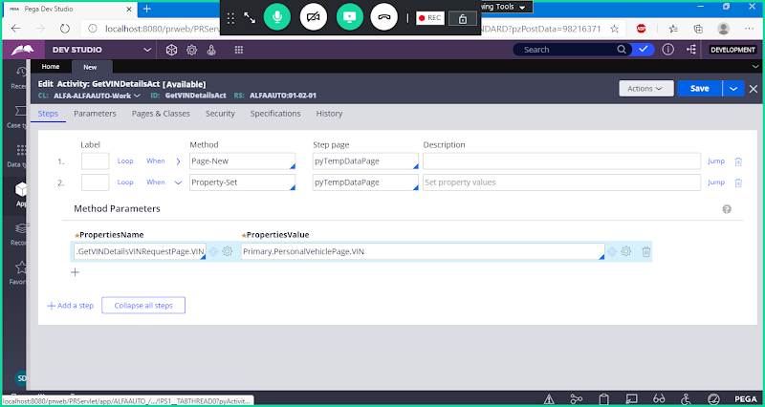

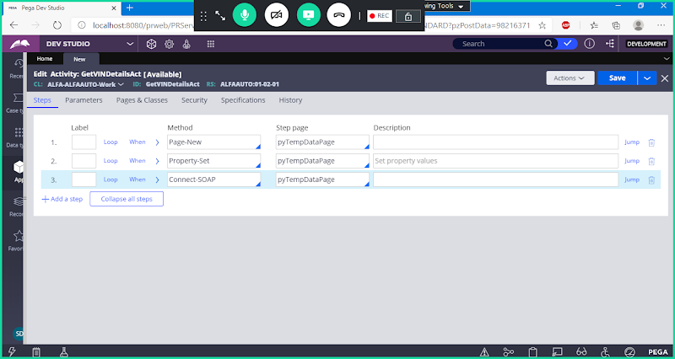

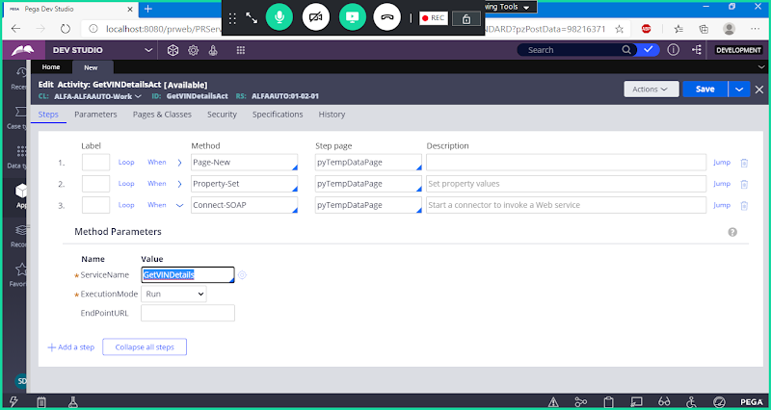

**Now add Property set Method After Connect SOAP to assign Response properties:**

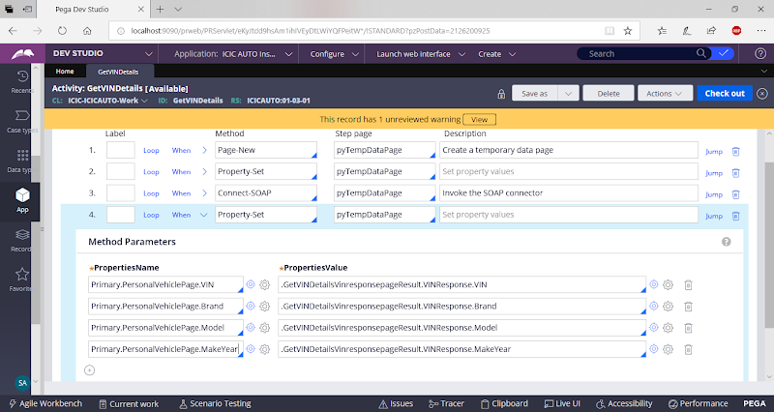

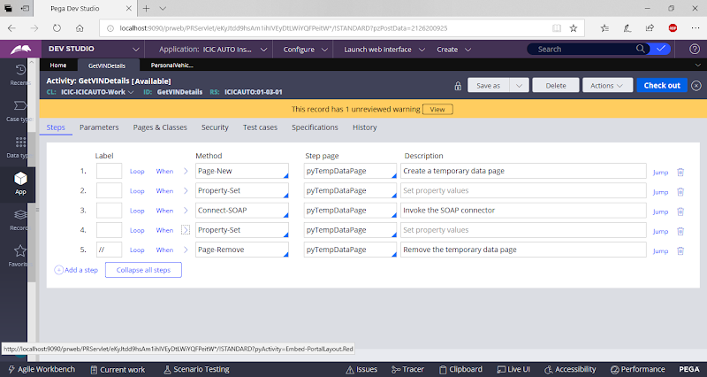

**Save Activity**

**Call this Activity in personal vehicle section on Click of Button.**

**Open Personal Vehicle Section**

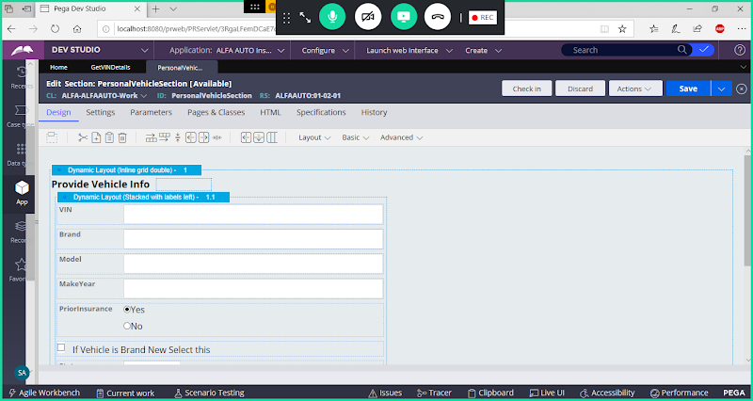

**Add Button & VIN Property**

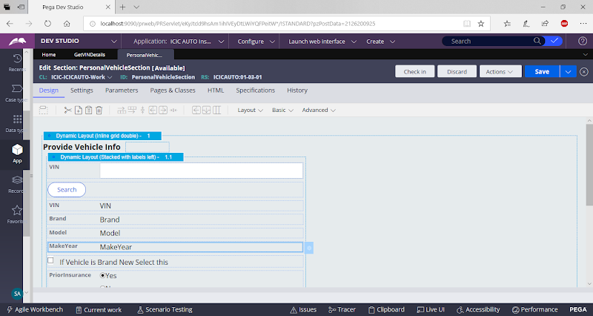

**Give Caption & Call Activity**

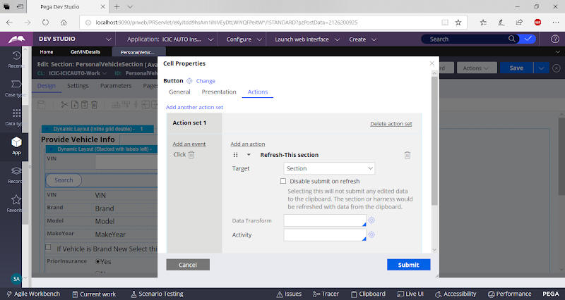

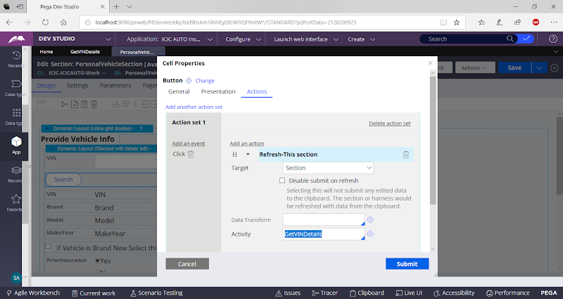

**Submit**

**Set Company, Model & Makeyear fields as ReadOnly Fields.**

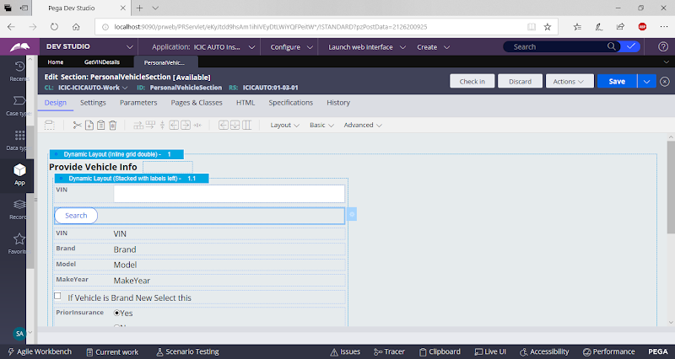

**Save & Check in**

**Execute Insurance Flow**

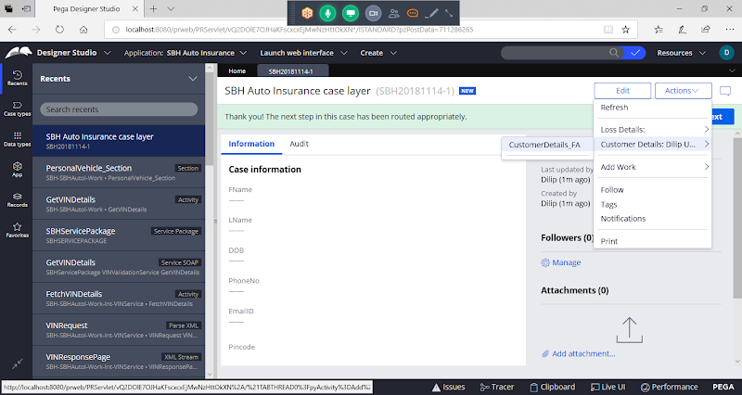

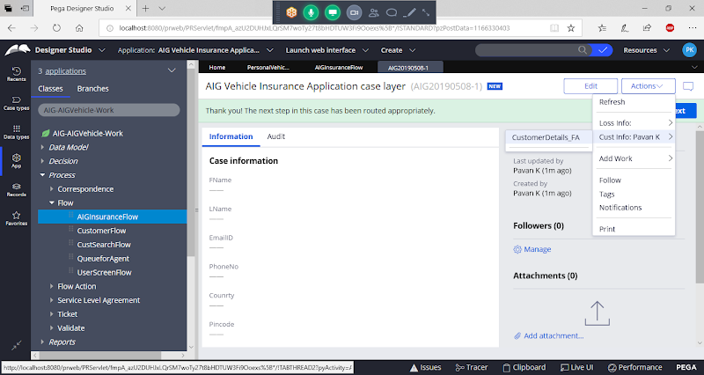

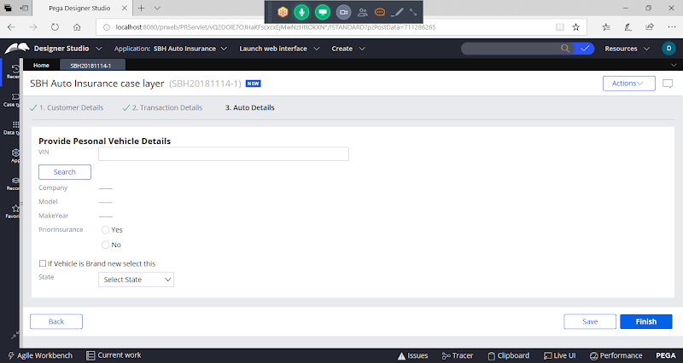

**Give VIN:**

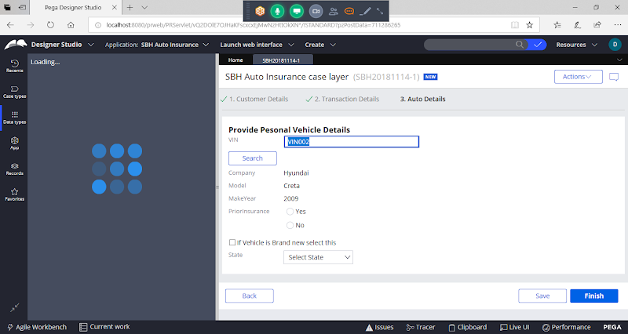

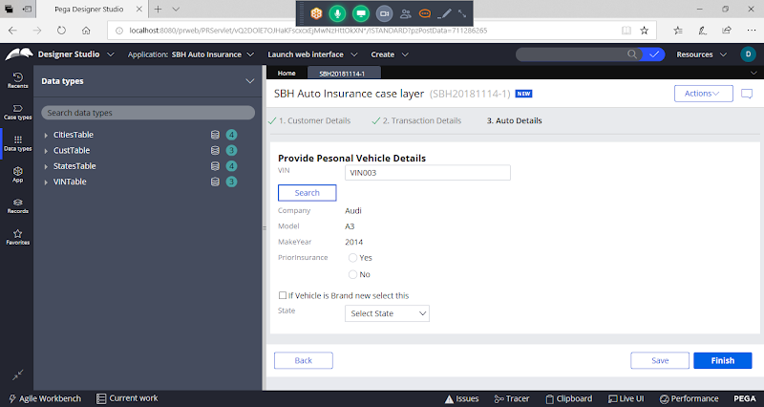

**=============**

**Connector Activities we can call in 2 ways:**

**In Section - Button Settings / in Input Property**

**In Flow - We need to Use Integrator Shape to call Connector Activities**

**Start-----Ass1-----Integrator------Ass2------End**

**==========**

**Connect REST:**

**REST Ful Services:**

**XML**

**JSON : { )**

**groupkt.com**

**http://www.groupkt.com/post/f2129b88/free-restful-web-services-to-consume-and-test.htm**

The url for this web service is:

[http://services.groupkt.com/country/get/iso3code/{alpha3_code](https://www.google.com/url?q=https://www.google.com/url?q%3Dhttp://services.groupkt.com/country/get/iso3code/%25257Balpha3_code%26amp;sa%3DD%26amp;source%3Deditors%26amp;ust%3D1620642153786000%26amp;usg%3DAOvVaw3Rgp5dnBPTDmg9mQymNcdT&sa=D&source=editors&ust=1620642153813000&usg=AOvVaw2shOpbpObYCAevY-dEeL3C)}

[http://services.groupkt.com/country/get/iso3code/](https://www.google.com/url?q=https://www.google.com/url?q%3Dhttp://services.groupkt.com/country/get/iso3code/%25257Balpha3_code%26amp;sa%3DD%26amp;source%3Deditors%26amp;ust%3D1620642153787000%26amp;usg%3DAOvVaw2k7yzPl72wEWmpgyNjpUhw&sa=D&source=editors&ust=1620642153813000&usg=AOvVaw1KnHEQX6tym5RlxZ9EARky)IND

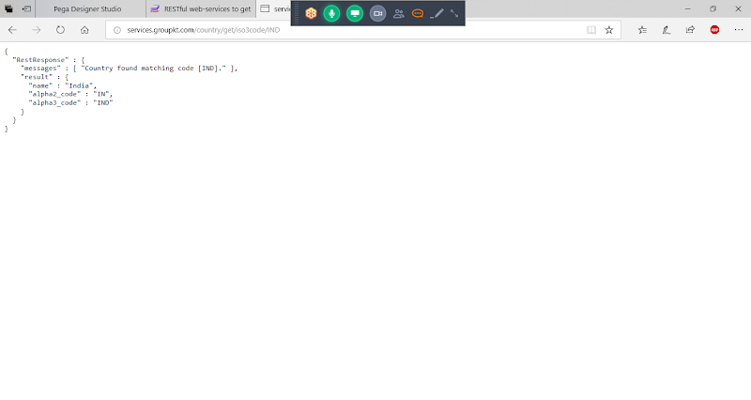

**Connect - REST:**

**Creating REST Integration:  Open REST Connector Wizard:**

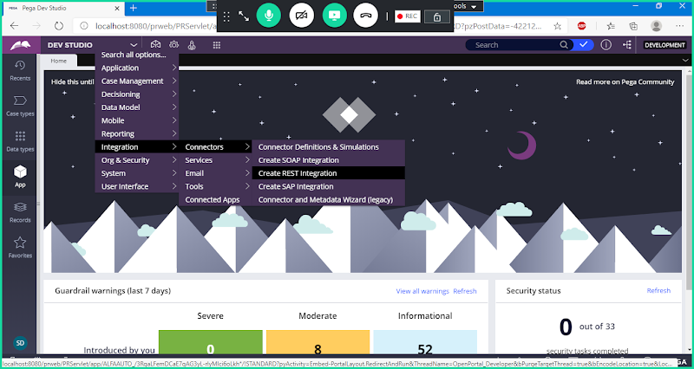

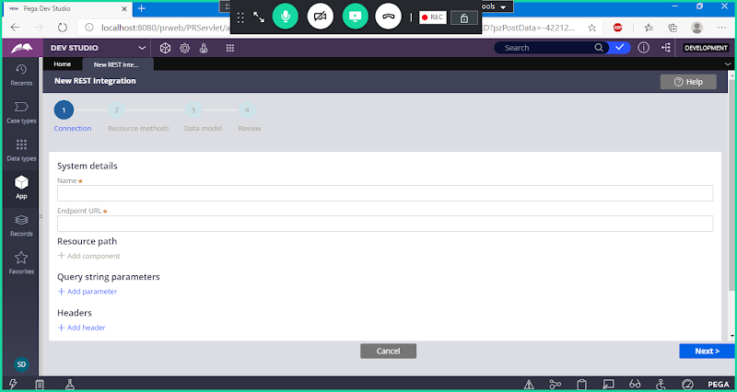

[http://services.groupkt.com/country/get/iso3code/{alpha3_code](https://www.google.com/url?q=https://www.google.com/url?q%3Dhttp://services.groupkt.com/country/get/iso3code/%25257Balpha3_code%26amp;sa%3DD%26amp;source%3Deditors%26amp;ust%3D1620642153788000%26amp;usg%3DAOvVaw1SX7Gy7tEEcXOCmGod8Tk7&sa=D&source=editors&ust=1620642153813000&usg=AOvVaw0DpX5K2yNhFcsJuBEt_HR7)}

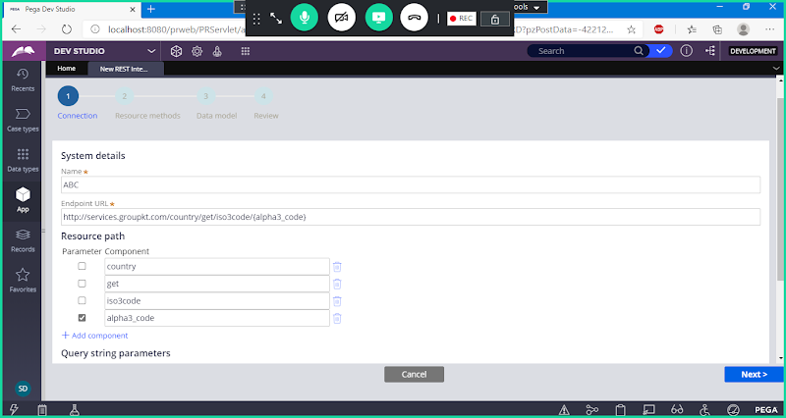

**Next**

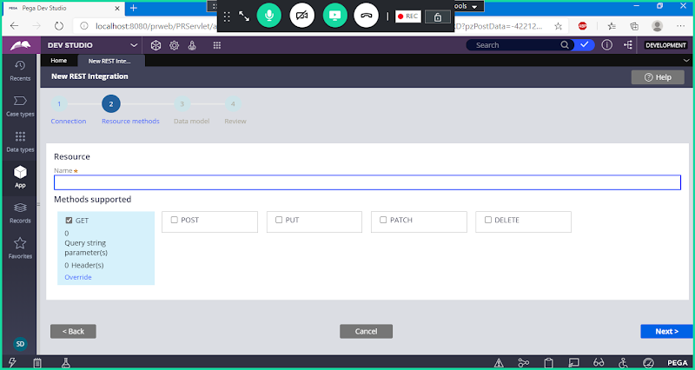

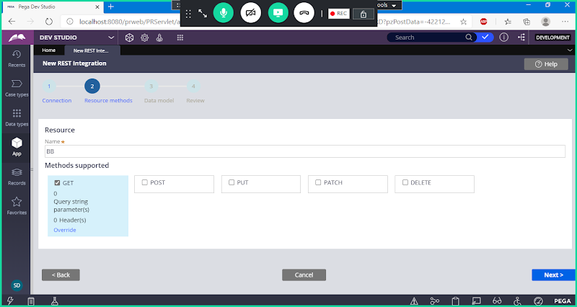

**Next**

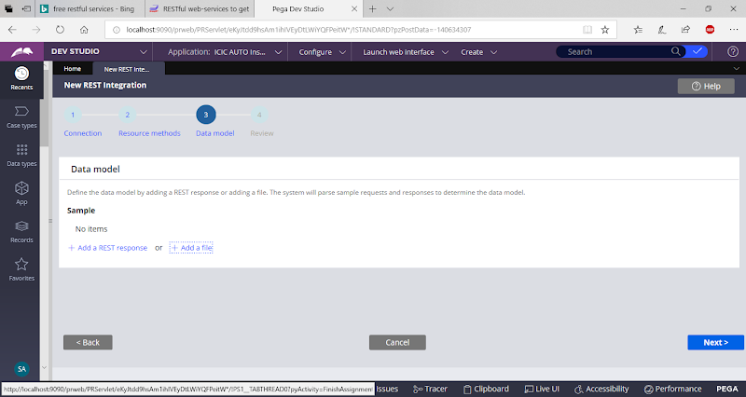

**Add Rest Response ( Means adding Respoonse Properties- Use Add a File)**

**Add a file**

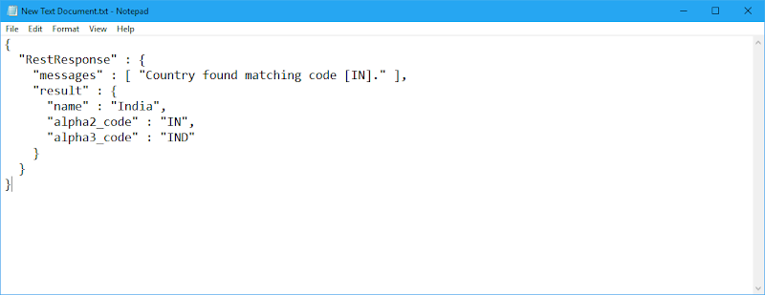

**Copy Rest Response:**

**Click on Add a File->**

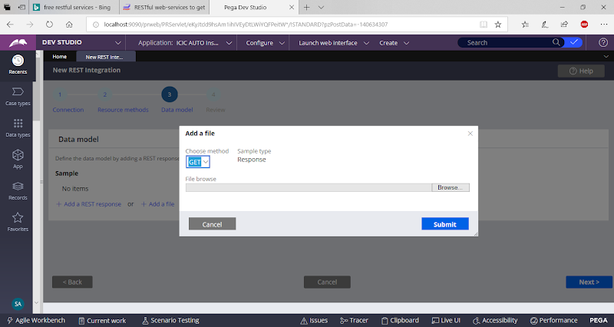

**Browse**

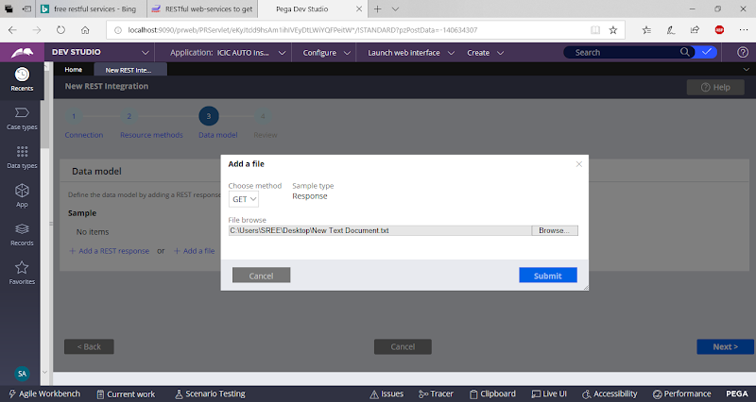

**Submit**

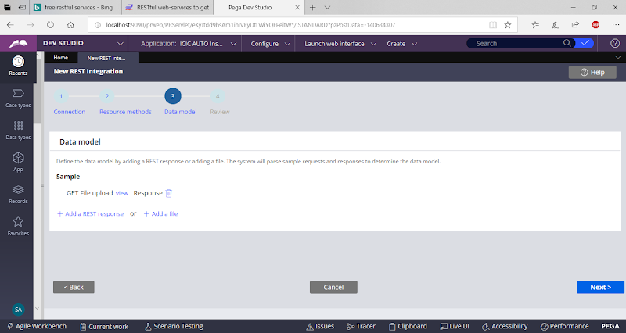

**or  Add Rest Response Automatically**

**Click on Add a Rest Response**

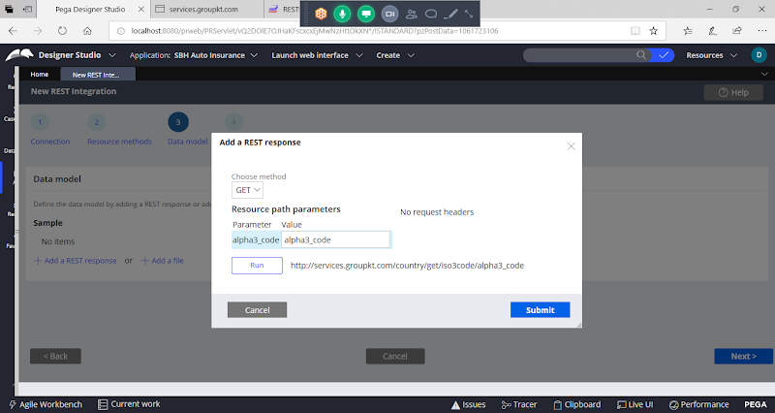

**Give Value: IND**

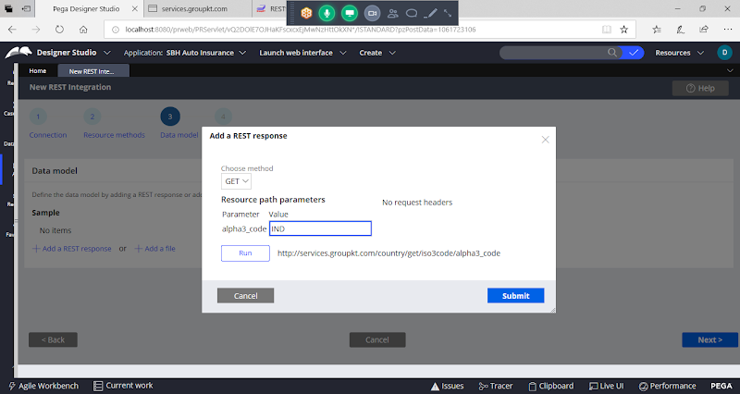

**Click on Run**

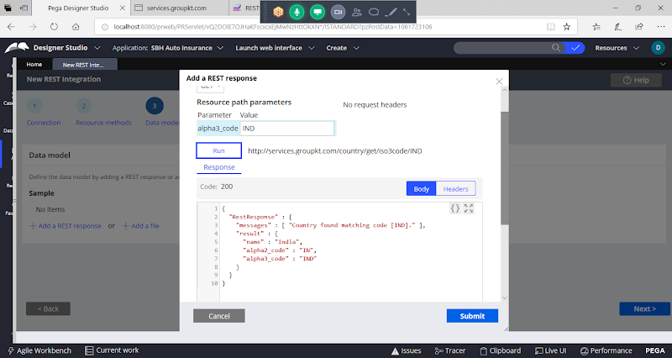

**Click on Submit**



**Next**

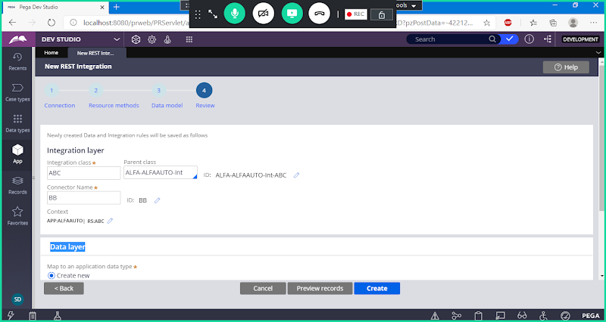

**Click on Create**

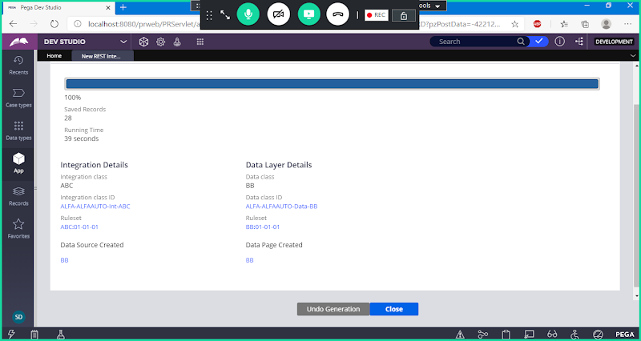

**Open Data Page**

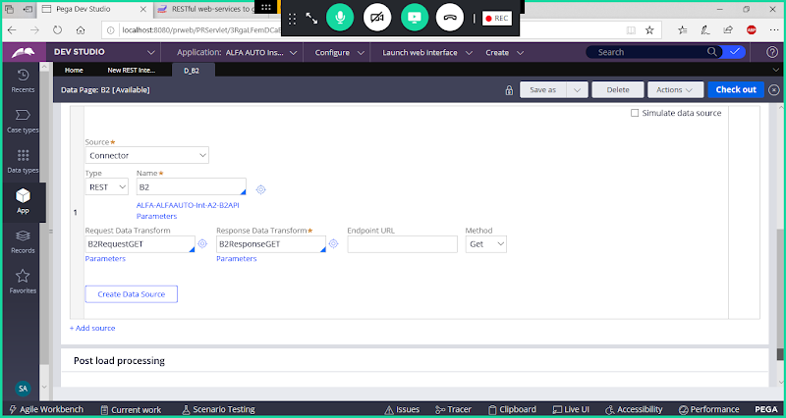

**Click on Close**